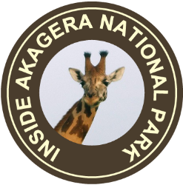

1 Days Wildlife Safari to Akagera National Park.

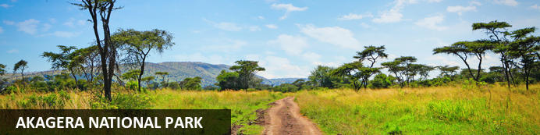

.

1 Days Wildlife Safari to Akagera National Park.
Akagera National Park
1 Days
.

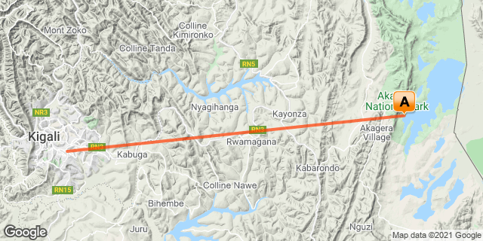

Included
• Exclusive use of a private safari land cruiser 4x4
•Picnic Lunch at for the day.
•Park fees.
•Boat Ride in Akagera National Park.
• Game drives
•Services of a professional, experienced English speaking driver-guide
•Bottled mineral water in the vehicle during the tour
• Our assistance

Excluded
- International and domestic airline tickets unless where indicated,
- All extra activities, visits, entrances, and extra meals/drinks not mentioned in the itinerary
- Entry visa fees,
- Optional extras indicated
- Premium Drinks throughout the trip,
- Tips and gratuities,
- Personal expenses such as telephone calls, mini bar, porter-age, travel insurance, etc.

Day 1: Akagera National Park

Akagera National Park
Bordering Tanzania in eastern Rwanda, Akagera National Park is central Africa's largest protected wetland and the last refuge for savannah-adapted species in the country. Stretching across a vast expanse of low-lying mountains and savannah plains, the park takes in the rolling highlands woodlands, swamp-fringed lakes, and wetlands of the Kagera River along the way. Crocodiles and hippos wallow in the park's watery basins, predator’s prowl through its acacia groves, and elephant, zebra, giraffe, buffalo and other animals roam across its grassy plains. Bursting with a rich biodiversity, the park features a variety of rare species, as well as a plentitude of mammals and hundreds of bird species.

Day Itinerary
- 0500: Begin the day with a convenient drive to Akagera National Park.
- 0730: Arrival at the Akagera National Park.
- 0800: Entry to the park for a mini game drive
- 0900: Boat ride on Lake Ihema.(scheduled)
- 1130: Boat trip ends. Pick up lunch boxes from Akagera Game Lodge.
- 1200: Full game drive starts towards the northern side
- 1400: Lunch break
- 1500: Continue with your game drive
- 1730: Exit the park from the north gate and return to Kigali
- End of service.

Activities
Boat Trip On Lake Ihema
Game drive

Basis
Lunch

